Data Cleaning and Analysis with Open Refine

# **Workshop data folder link:** [**go.ncsu.edu/refine**](http://go.ncsu.edu/refine)

# **Open Refine**

Open Refine (formerly Google Refine) is a data manipulation and cleaning tool that runs in your browser. The data is not stored online.

Open Refine allows you to clean data and it saves all of your edits as steps, which you can Undo and Redo (unlike in Excel)

If you know how to use regular expressions, Open Refine is even more powerful.

GREL ([*OpenRefine Expression Language*](https://github.com/OpenRefine/OpenRefine/wiki/General-Refine-Expression-Language) *(GREL)* is a programming language for Open Refine that allows you to do many types of manipulations of the data. We will use it in this workshop.

**To open the software:**

Press command + Space Bar: type in “Refine”

Or, search for it in the Applications folder

Download this data set from the data folder:

**NC_LEED_2002-2010.csv**

In Refine, click “Create Project”

Choose Files > Open > Next

Click **Create Project**

Click on Show 50 Rows to see more data

You can see your data by clicking on **first/previous/next/last** options in the menu:

Screen Shot 2016-01-05 at 12.32.58 PM.png

Scanning over the data we can see that it is pretty clean, but there are some things that need to be changed.

**1. Fix inconsistencies in upper/lower case**

Click on the down arrow in the **name** column

Select Edit Cells > Common Transforms > To titlecase

This should make all values in the cells have a capitalized first letter of each word

**2. Cluster and edit column owner_organization**

owner_organization > Facet > Text Facet

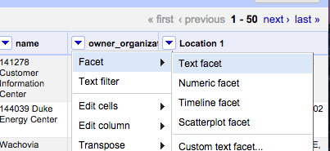

in the left column, click the Cluster button

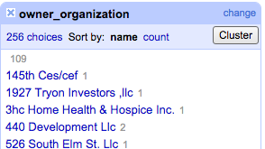

Here you should be able to edit any inconsistencies in organization names.

Choose what you would like to Merge then Select **“Merge Selected & Re-Cluster”**

Select different options of clustering algorithms from the “Key Function” dropdown menu to find different potential clusters.

**3. Edit directly in the cluster menu**



Here you can scroll through and manually edit based on any errors you find. Click on edit to the right of the name of the item.

**4. Separate address from Lat/Longitude**

In Location 1, choose Edit column > Split into several columns...

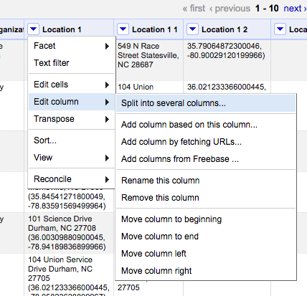

Type in the open parenthesis sign “(“ as the delimiter value (without quote marks)

This should split the column so that the address is in its own column.

**5. Split the column that has latitude and longitude values:**

Edit column > Split into several columns…

“,” as the delimiter

rename latitude column (Edit column > Rename this column)

**6. Remove trailing parenthesis ) from longitude column**

Edit cells > transform

In the expression box, type or copy/paste the following:

**value.replace(")", "")**

To make the longitude values into numbers (they are currently strings) type:

Edit cells…

Common transforms > To number

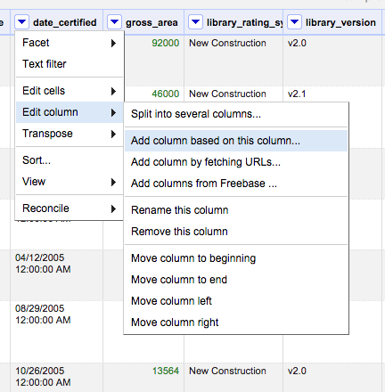

**7. Create a new column for the year only.**

date_certified column, click on the down arrow

choose **Edit column…**

then **“Add column based on this column...”**

Type in a new column name

In the Expression window that pops up, type the following formula:

**value.toDate('MM/dd/yy').toString('yyyy')**

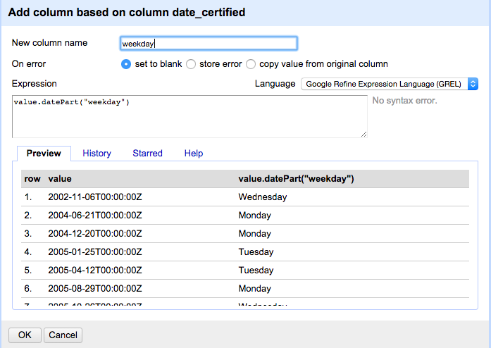

This will convert the date that you have from its current format (MM/dd/yy) to the the 4-character year (‘yyyy’)

**8. Add a weekday field based on the date_certified colum**

choose **Edit column…**

then **“Add column based on this column...”**

**value.datePart(“weekday”)**

9. Change date_certified column to mm/dd/yyyy format

**toDate(value,"dd/mm/YYYY H:m:s").toString('MM/dd/yyyy')**

# **Using Extract/Apply to Clean Future Datasets**

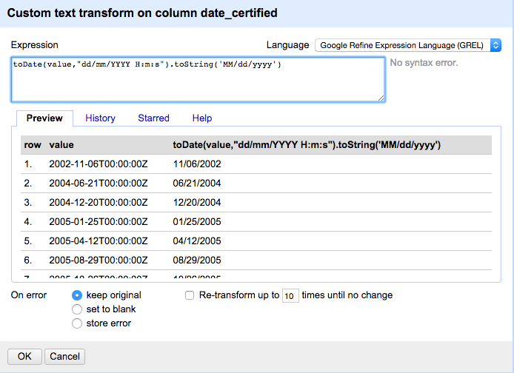

With Open Refine, you can save your work and apply those changes to future data sets!

Here’s how:

On the left hand column, click Undo/Redo

Click the Extract button

Make sure all values are selected (they should be highlighted blue). command +A to select all

Copy with command + c

Open Text Edit on your Mac (or any text editor). Paste the JSON code in there

Now load **NC_LEED_2011 2014.xslx** data set into Refine

Open > Create Project > Choose files > NC_LEED_2011 2014.xslx > Next> Create project

This data set is structured the same as the previous one, only different years.

Click Undo/Redo

Click Apply

Paste the JSON code into the window and click **Perform Operations.**

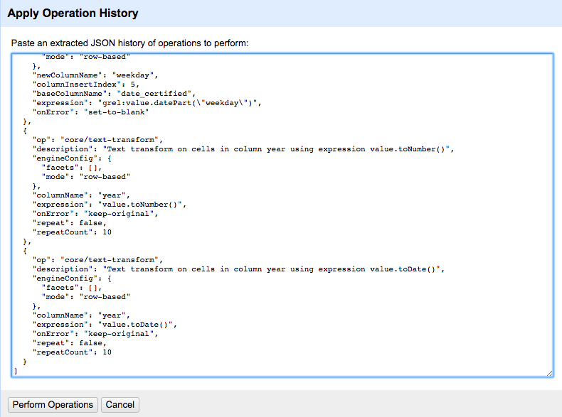

10. Find the blanks in **name** column

In name column, select Facet > Customized facets > Facet by blank

This will give you a facet window on the left-side of the screen with “true” and “false” groups.

The “true” group are all of the rows with a blank value for this column. Click on true to find all of the blanks

To exclude the blanks, click exclude

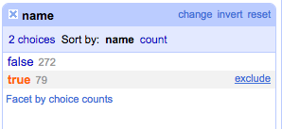

**11. Subset the data by creating a numeric facet on the gross_area column**

This gives you a slider where you can filter by range of values to see a subset of the data. Move the slider in the facet window to select a subset.

Gross_area column dropdown arrow > Facet > Numeric facet

**12. Export the data**

Click Export and choose your preferred file type.

**13. Going farther with Open Refine: Data Augmentation**

There is much more that you can do with Open Refine, for example, to bring data in from the web in various formats.

**For example: Finding lat/longitude data from the web, given an address: (this can take awhile depending on the size of the dataset)**

Find the column with the street add (Location 1) column in the LEED data set, click the dropdown arrow

Choose **Add column by fetching URLs…**

Type this into the expression window:

"http://nominatim.openstreetmap.org/search?format=json&app=google-refine&q=" + escape(value, "url")

This column will retrieve a lot of data in json format that then needs to be parsed.

See this video for more information: <https://www.youtube.com/watch?v=5tsyz3ibYzk>

### **Test Yourself!**

Now try doing some data cleaning in OpenRefine with the “**practice data.xslx**” file in the materials folder.